|  |  |
| --- | --- |
|  | THE GOODS AND SERVICES TAX APPELLATE TRIBUNAL |
|  |  |
| April 2022 | A Concept Note |
|  |  |

THE GOODS AND SERVICES TAX APPELLATE TRIBUNAL

A Concept note

Background

Since the introduction of the Goods and Services Tax in India more than four years ago, we have seen a steady rise in litigation as taxpayers are often faced with ambiguous legal provisions. The situation has been exacerbated due to the non-constitution of the GST Appellate Tribunal (GSTAT). The first level of appellate decisions is accumulating against assessees awaiting the setting up of the GSTAT to provide clarity on a host of issues. Others have been constrained to approach the High Courts for relief, thereby adding to the latter’s workload. In September 2021, the [Supreme Court](https://www.livelaw.in/top-stories/gst-appellate-tribunal-supreme-court-pulls-up-central-govt-for-indefinitely-delay-of-gst-appellate-tribunal-constitution-179034?infinitescroll=1) directed the government to set up the GSTAT without any further delay to avoid hardships caused to litigants and to curb the huge backlog of cases.

The GSTAT presents a greenfield opportunity to build a completely online dispute resolution system that can significantly ease doing business and signal the Indian government’s intentions on solving tax disputes fast and economically without compromising revenue interest. A state-of-the-art dispute resolution institution backed by a constitutionally sound legal framework would require well-drafted rules and regulations to be put in place for its functioning.

Set out below are recommendations/proposals that we believe are necessary for establishing and functioning a truly modern GSTAT:

Constitution of a new tribunal - the GSTAT and its benches

GSTAT should be set up as a new tribunal as subsuming it under existing CESTAT may not be legally sound/practical. GSTAT, being a forum where both the Centre and the states have significant interest, should have representation from both levels on its benches. Customs and Excise duty, being central taxes, do not need state representation on the tribunal bench. Further, if CESTAT were to take over the role of GSTAT, the sudden deluge of pending GST appeals could cripple the functioning of the CESTAT itself and lead to further delays and pendency.

Area benches of Tribunals should be located away from the state capital. (Karnataka is a case in point where both area benches are notified to be set up in Bangalore, thereby forcing taxpayers from Mangalore and Belagavi to travel to Bangalore or engage representatives in Bangalore.)

The procedure for the transfer of tribunal members (both technical and judicial) to tribunals in different states must be provided in a manner similar to that in CESTAT/ITAT. We have seen that a lack of such provisions in the Sales Tax Tribunal led to local cadre members staying in their home states.

GSTAT is the forum for the second appeal in GST laws and the first common forum of dispute resolution between the Centre and States. The appeals against the orders in first appeals issued by the Appellate Authorities under the Central and State GST Acts lie before the GST Appellate Tribunal, which is common under the Central as well as State GST Acts. Being a common forum, the GST Appellate Tribunal will need to ensure uniformity in the interpretation of and redressal of disputes arising under GST law.

An appeal from GSTAT order directly to the Supreme Court should be permitted in certain specific types of cases like those involving issues like place of supply, classification, valuation etc (such a practice is available under CESTAT). This will prevent multiplicity in interpretations of these provisions of law by various jurisdictional High Courts. (Refer to Illustration 1 below)

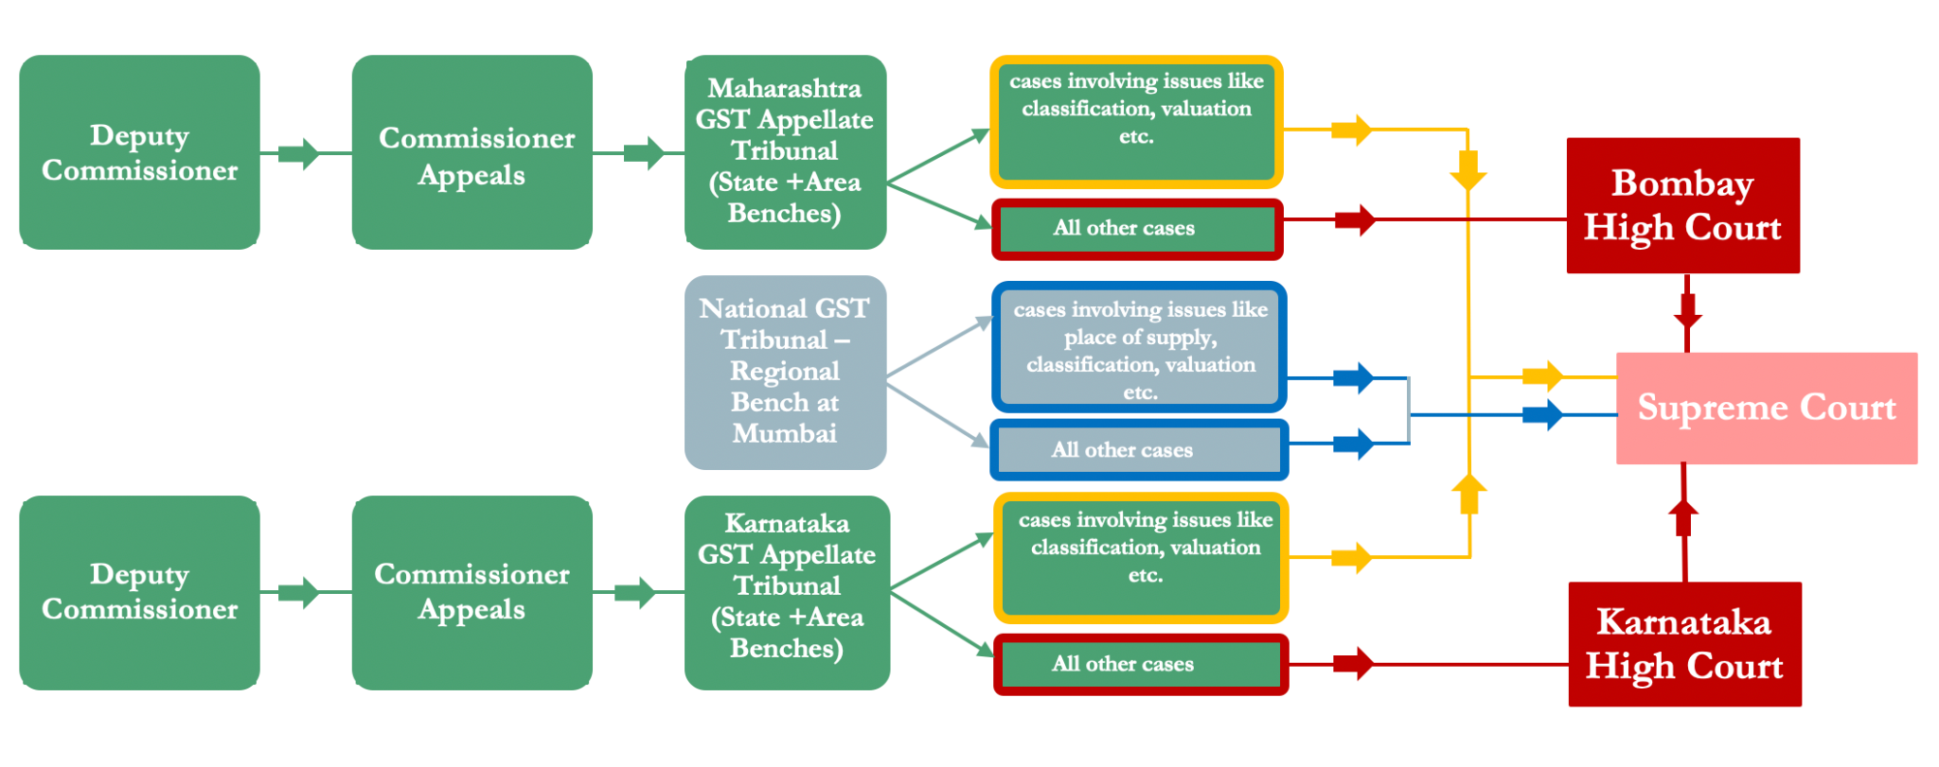

Smartly designed technological processes

es

The entire lifecycle of a case, from filing to disposal, digital signing of judgments etc., should be entirely digital.

Filing of documents (procedure and language) and appeals using online forms and drop-down menus can be substantially standardised to enable easy scrutiny and case management. By integrating it with the GST system, the need for filing the first appellate order or other documents already filed before adjudicating authority/first appellate authority will not be required as the GST System could pull those orders by quoting the unique order number given to the order of first Appellate Authority. Such integration will also ensure that the tribunal’s order automatically flows into the GST System, obviating any need to file the order and manual data entry by GST officials.

A better docket management system which prioritises cases for listing and hearing (ensuring old cases are concluded in a time-bound manner, high revenue matters are addressed, repeat matters are segregated, etc.) must be put in place.

Developing smart checklists to validate appeals filed can pre-empt errors that can derail the resolution of the matter late in the process. The GSTAT must have a seamless and paperless workflow where back-end functions like scrutiny and case management can be done online.

Hearings must be permitted on virtual mode as the default unless the taxpayer opts for physical mode. Software modules are already available on GSTN, and these may be integrated with other video tools based on factors such as bandwidth requirement, open-source, etc. It must, however, be ensured that virtual hearing doesn't skew the entire system in favour of a select few senior lawyers and thereby prevent the growth of a new crop of upcoming lawyers in this field in the long run.

Software Platform

es

All benches with separate databases should use one software application. This will ensure uniformity of processes and facilitate automation. Changes will only have to be made once rather than separately for each tribunal. Not only will it save cost and resources, but it can also be developed and deployed faster. (GST officials of 12 States started with a common application with separate databases in 2017. By 2022, apart from four states, the other states have adopted the common application developed by GSTN and run and operated by them).

The workflow process of the GSTAT will be similar to that of the first appellate authority. GSTN has developed the software being used by the First Appellate Authorities across the country. The same could be modified and upgraded for use by the GSTAT. It will be faster and cheaper to get this work done by GSTN, who have experience in managing the GST System. Also, the integration will be much tighter.

The GSTAT software should be developed as a platform that will allow solutions to be configured and customised on top of it through APIs.

Rules and Procedures

Procedures and templates for filing appeals/ applications - must allow the appellant to produce all relevant documents and material so that there are no delays in the movement of files from adjudicating authority and first appellate authority to the Tribunal (this will become automated if the Tribunal System is integrated with GST System, as explained above).

Procedures for hearing of appeals – such as date and place of the hearing, recording of the hearing, cross-objections, ex-parte hearing, and production of evidence/additional evidence before the Tribunal should be clearly spelt out.

The concept of ‘written statement’ must be introduced so that the respondent does not urge new grounds during hearings.

The concept of ‘interlocutory applications’ must be allowed right from the first appeal for a limited number of grounds, such as questions on limitation, jurisdiction, etc., which are often glossed over.

As a one-time transitional mechanism, alternative dispute resolution (ADR) can be considered as a voluntary step after the filing of appeal but before listing of cases for disposal. Some form of concessions/incentives may be considered for those who opt for ADR. Matters that fail to be resolved in ADR can continue to be heard by the Tribunal.

Case Flow Management Rules for GSTAT should provide for:

* developing norms/rules for prioritisation of cases - based on the subject matter, types of litigants, the amount under litigation, etc.;
* timelines for filing of the memorandum of appeal/ application, and written statement, timelines for different stages of appeal and adjudication of the matter etc.;
* the bifurcation between procedural and substantive work (some procedural work like early hearing applications, transfer applications, additional documents filing etc.) can be handled by the Registry itself;
* The President/Chairman being the master of the docket. They must set limits on the number of cases to be listed on a particular day;
* putting up two cause lists with stage-wise division indicating procedural and substantive stages;
* procedures for issuing notices to ensure that service is taking place promptly without any delay and providing legal backing for delivery through technological media; and
* rules discouraging excessive adjournments like higher filing fees if the number of adjournments exceeds a threshold number, refusal of early hearing and other benefits if the assessee takes adjournments frequently, etc.

Other changes

Exploring ways to reduce the number of cases admitted through the use of checklists, employing artificial intelligence, etc. and harmonising thresholds for filing appeals with administrative practice guidance notes.

Next Steps

* Law Committee of GST Council to formulate a legal framework for the new GSTAT as envisaged and circulate with other members within GST Council.
* Draft changes to legal framework for GSTAT to be put out in public domain for public comments by the Law Committee of GST Council after internal deliberations.