**Not Quite Rocket Science**

What judiciary can learn from institutional reforms and processes transformation from developments in India’s space sector?

If you haven't already seen the [recent video](https://www.youtube.com/watch?v=nVNIoQUcFI4) of a 30-storey high rocket coming back to its station without a glitch, I would urge you to do it now. It made me wonder how much space technology has evolved over the last few years and about what lies ahead. The space exploration scene in India too has been buzzing with activity. In September 2024, India announced Chandrayaan-4, a groundbreaking mission, with a budget of about Rs 2,100 crores. Led by the Indian Space Research Organisation (ISRO), Chandrayaan-4 will be launched in 2027 to lay the foundation for India's ultimate goal of landing astronauts on the Moon by 2040.

This follows a flurry of activity in India’s space sector over the last few years. India now allows 100% Foreign Direct Investment (FDI) in most areas in the space sector, we are collaborating withNASA and the European Space Agency, and an Indian Space Policy 2023 is in place. The Indian Space Policy 2023 has made a significant shift. It allows non-government entities to undertake end-to-end activities in the space sector through the establishment and operation of space objects, ground-based assets and related services, such as communication, remote sensing, navigation, etc. subject to guidelines/regulations prescribed by a new institution the Indian National Space Promotion and Authorization Center (IN-SPACe). IN-SPACe set up in 2020 is an autonomous Government organisation is mandated to promote, hand-hold, guide and authorise space activities in the country by periodically issuing guidelines and procedures that would among other things promote ease of doing business. The NewSpace India Limited (NSIL), a Public Sector Undertaking (PSU) of the Government of India under the Department of Space (DoS) set up in 2019 is now responsible for manufacturing, leasing, or acquiring space components, technologies, platforms, and other assets from the public or private sector with the help of an industry consortium.

To facilitate the functioning of the new organisations, the Indian Space Policy 2023 has defined the roles and responsibilities of the Indian Space Research Organization (ISRO) and the DoS. Most importantly, ISRO is transitioning out of its current role of being present in the manufacturing of operational space systems and is transferring mature systems to industries for commercial usage. ISRO is now focusing on R&D in advanced technology and the realisation of space objectives to meet national prerogatives. This will enable ISRO to focus all its resources on long-term initiatives like Gaganyaan as well as cutting-edge research and development.

A schematic representation of the new structure of these institutions as available on the ISRO website is here:

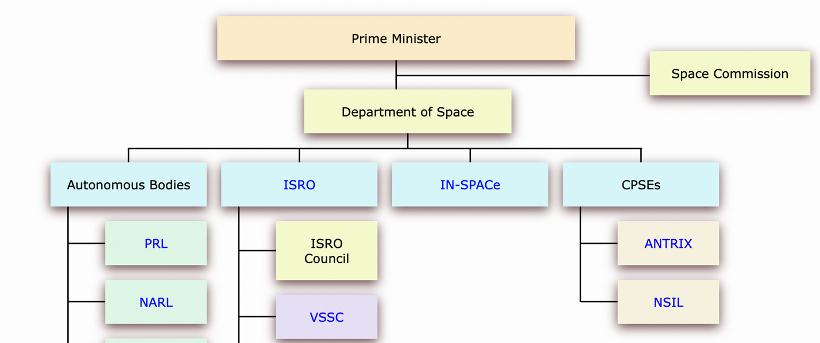

This is not to say that there is no scope for improvement. For instance [it has been pointed out](https://takshashila.org.in/research/space-reforms-in-india) that IN-SPACe should not be under the Department of Space, mechanisms to handle disputes must be put in place, and the policy must be further crystallised as a legislation. However it is impotrant to draw attention to the significant shift undertaken in a sector which has traditionally been dominated by one large public organisation, ISRO, with a long-standing public perception of being a high performer.

The key takeaway for me here is the new institutional design: clarifying the roles of institutions relevant to their core expertise; encouraging private sector participation and carving out new institutions for achieving larger objectives.

There are learnings from these developments to the institutional design of other sectors. I will dwell into those for our law and justice system. Not much attention has been paid to how institutional design affects the rule of law in our country. The popular discourse is dominated by demands for capacity enhancement (more judges, more courts, more forensic labs), debates on who appoints whom, and since the COVID pandemic, on using technology. Given the large complex system that the law and justice system is, in addition to the above, there is also a need to view with fresh eyes the mandate of all the institutions involved in ensuring the Rule of Law, their processes and practices rules they follow, and their manner of interaction with each other.

Let's take forensic labs for instance. For some years now many have flagged how [delay in obtaining reports](https://timesofindia.indiatimes.com/city/delhi/courting-trouble-how-endless-wait-for-forensic-reports-is-delaying-justice/articleshow/88244533.cms) by forensic labs has affected justice delivery. This is the situation across the country. The Union Government is expected to spend about [Rs.4500 crores over the next 4 years](https://pib.gov.in/PressReleaseIframePage.aspx?PRID=2036389) to enhance the quality of existing labs and establish new ones. This is especially important given that the Bharatiya Nagarik Suraksha Sanhita and the Bharatiya Sakshya Adhiniyam that have come into effect from July 2024 have rationalised and expanded the role of electronic and digital evidence. However, there is no indication of how private forensic labs could be leveraged for timely justice delivery.As [has been pointed out](https://p39ablog.com/2023/11/criminal-law-bills-2023-decoded-17-forensic-evidence/#:~:text=a.,problematic%20and%20should%20be%20reconsidered.), engaging with private forensic labs would require regulating them to ensure quality and compliance with professional and ethical standards. This would require a higher level of engagement by current institutions such as the directorate of forensics, the police, the prosecutors and the courts.

The situation is similar with technology. In 2023, the Union Cabinet [approved Rs. 7210 crores for eCourts Phase III](https://doj.gov.in/phase-iii/) for the technological transformation of courts. Based on the radically transformative [vision](https://ecommitteesci.gov.in/document/vision-document-for-phase-iii-of-ecourts-project/) for the Phase III, the main objective of the Phase-III is to build digital courts “which will provide a seamless and paperless interface between the courts, the litigants and other stakeholders.” This is being implemented under the partnership of Department of Justice, Government of India, eCommittee, Supreme Court of India, in a decentralised manner through the respective High Courts. State governments are expected to supplement funding for eCourts Phase III.

It is critical that policy makers in the government and the judiciary think through how private players could be engaged actively to make this a success. This would require enhancing the capacity within the judiciary in writing out clear Requests for Proposals, tendering, contracting, quality testing, and tackling any performance issues (imagine the plight of a vendor who has to face proceedings in a court against or by the same court!). Capacity enhancement would involve, among other things, bringing on board (preferably as full-time staff or at least as consultants for the medium term) specialists in various aspects of technology implementation like system architecture, coding, designing user interface and user experience, change management, and project management. High Courts should set up Technology Offices headed by a technology expert.

The vision for eCourts Phase III had also envisaged the setting up of a permanent entity backed by a statute: the National Judicial Technology Council (NJTC) (see Institutional And Governance Framework under Operationalising Phase III of the [vision](https://ecommitteesci.gov.in/document/vision-document-for-phase-iii-of-ecourts-project/) for Phase III). A extract of the schematic representation of the institutional structure as provided in the vision document is shared below:

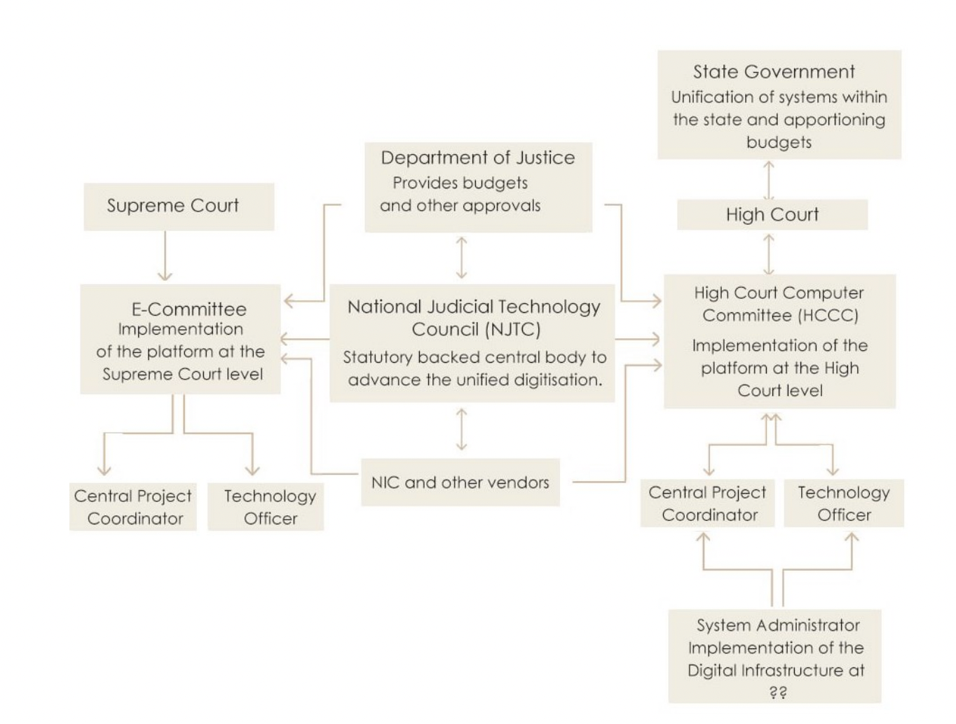

It was envisaged that, ‘as a statutory body, the NJTC would have continuity in its policy and operations, be vested with operational independence from the government, flexibility in funding appropriations and constitution of its governing and operational bodies whilst deriving its constitution, role, powers and functions from an Act of Parliament according to sanctity to its operations.” Its mandate would be “to advance the unified (not uniform) digitisation of the judiciary through design and creation of public goods and infrastructure for adoption by States, prescription of standards, specifications, and protocols, and to afford assistance to courts in adoption. In addition, the NJTC will play a key role in evolving model operational processes and guidelines for the setup of the proposed institutional structure (in a federated and unified manner)”. There is no word on where we are in the process of setting up the NJTC.

Reimagining legal and judicial processes, and institutional reforms are vital if access to justice must improve for the Rule of Law in the country. If critical sectors such as space and defence can do it, the judiciary does not have to look far for inspiration. It is no longer a leap of faith, nor is it rocket science.